Updated 12.31.19  29799 SW Town Center Loop East  Wilsonville, OR 97070  Phone: 503.682.4960  Fax: 503.682.7025  Web: www.ci.wilsonville.or.us |  |  | Public Improvements for a Single Family Home Site Worksheet  Engineering Division Approval Stamp  Building Permit #:
Builder:
Lot Address:
Lot Number: Subdivision:
Easements

PUE:
Arterial (10’):
Collector (8’):
Local (6’):
Other:
Single Utility (15’):
Combined Utilities: Per Engineer of Record and approved by City Authorized Representative
Sidewalks
Arterial (5’ Min):
Collector (5’Min):
Local(5’Min):
Detail Standard: RD-1075 Concrete Sidewalk
Planter:
Arterial (6’):
Collector (5’):
Local (5’):
Detail Standard: Per 201.2.25 Sidewalks Table 2.13 Sidewalk Separation From Roadway_
Driveway Approach

Minimum Width (12’):
Maximum Width (24’):
Detail Standard: RD-1090 Residential Driveway_
Sanitary Sewer, Stormwater & Water Services:

Sanitary Sewer Lateral
Material (PVC, ASTM d-3034, SDR35 or lower):

Size (4” Min):

Slope (2% Min):

Detail Standards: S-2175 Service Lateral

Curb Stamp: Yes ☐ No ☐

Storm Drainage Lateral
Material (PVC, ASTM d-3034, SDR35 or lower):

Size (6” Min):

Slope (2% Min):

Detail Standard: S-2175 Service Lateral

Curb Stamp: Yes ☐ No ☐

Water Service Lateral
Material (Soft Temper Type K Copper Tubing Complying with ASTM B-88):

Size (1”): Meter: Yes ☐ No ☐

Detail Standard: WT-3030 1” Single Service

Curb Stamp: Yes ☐ No ☐

LID is required when creates or revised more than 5000 square feet of impervious area
Type (Planter/Rain Garden/Filter Strip/Swale):

Size: N/A Storm Report Included: Yes ☐ No ☐

Planting Plans Included: Yes ☐ No ☐ Soil Medium Type:

HOA Stormwater Maintenance Easement Agreement: Yes ☐ No ☐

Private Stormwater Maintenance Easement Agreement: Yes ☐ No ☐

Detail Standards: ST-6005, ST-6010, ST-6020, ST-6025, ST-6035, ST-6045, ST-6050

Erosion Control

Construction Gravel Entrance: Yes ☐ No ☐

Sediment Fence: Yes ☒ No ☐

Garbage Can: Yes ☒ No ☐

Inlet Protections: Yes ☒ No ☐

Contours/Elevations: Yes ☒ No ☐

Concrete Washout: Yes ☒ No ☐

Detail Standards: S-2245 Sediment Fence, S-2240 Gravel Construction Entrance, S-2127 Inlet Protection Type 5, S-2126 Inlet Protection Type 4

Trees
Where trees are located within 8’ of public curbs, the curb shall be protected from root intrusion with a root control barrier.

Species:

Root Barrier: Yes ☒ No ☐

Detail Standards: RD-1240 Street Tree Location and Clearances
Staff Notes/Comments:
Date | Staff Name | Comments

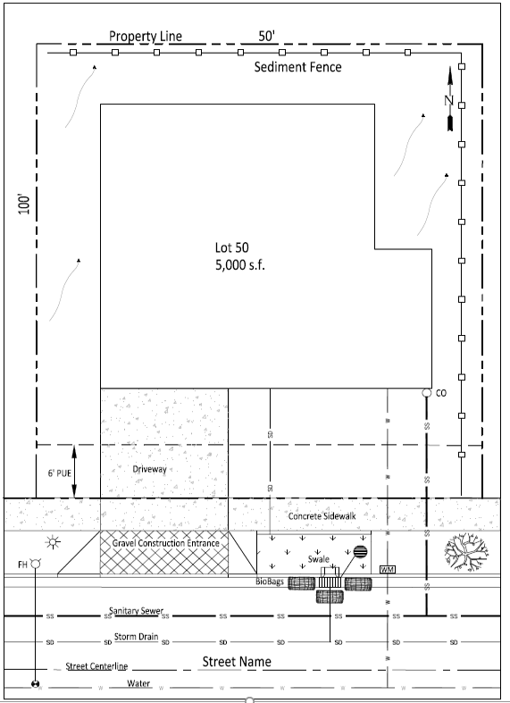
SAMPLE SITE PLAN

